**EAD CA2 Project – Price Compare**

**APP Overview**

This application is used to compare the value of products using their price and brand value to compare which is the better deal for your money.

**DB schema**

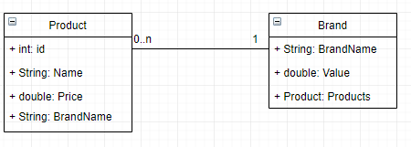

**UML Class Diagram**

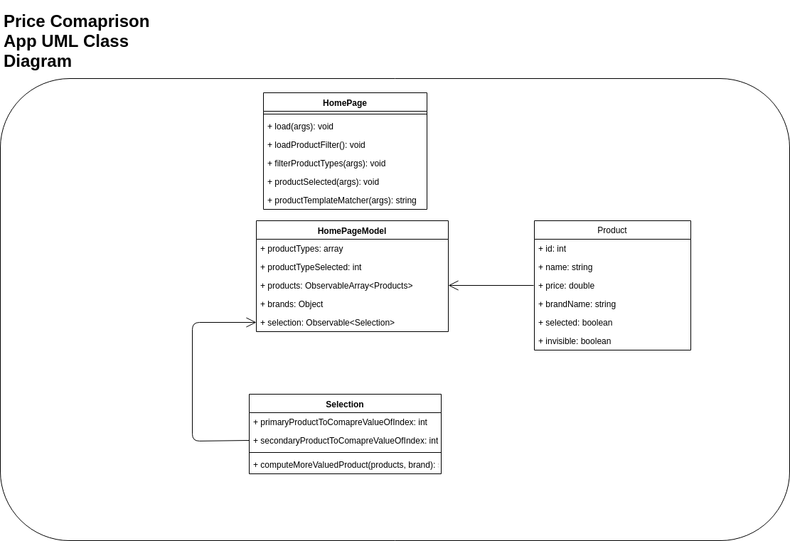

**Azure specs**

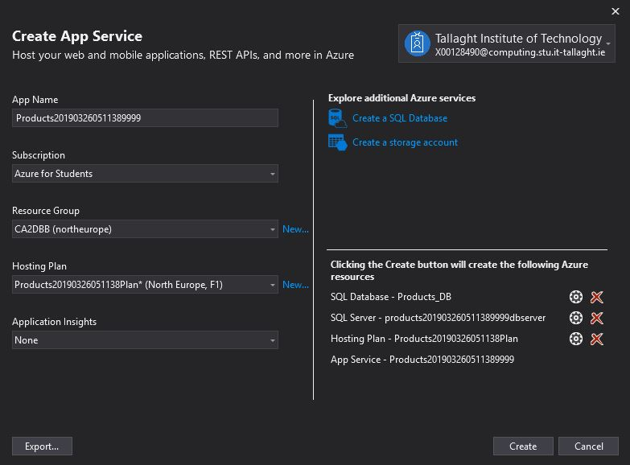

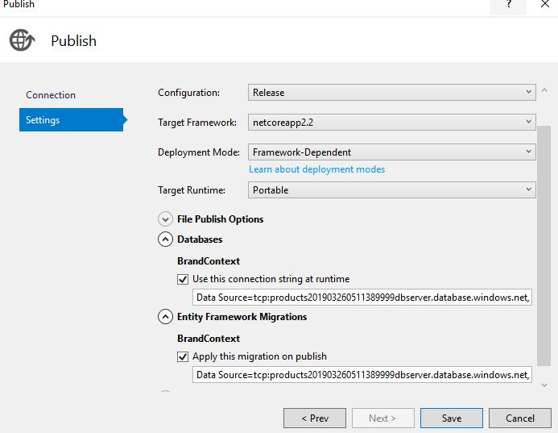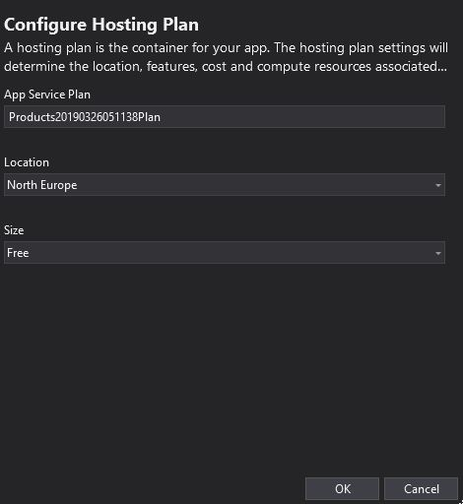

**Test report**

Tests not working.